A brief user guide for pyPEDM
Follow these steps to configure your system and run the pyPEDM (pyPEDM_demo.py) for processing LA-ICPMS fission track data. See Tian and Zhong (2026, G-cubed) for methodology. Please kindly let me know, when noticing bugs.

1. Install IsoplotR for R
- Install the IsoplotR package of Vermeesch (2018) in R. Detailed installation guides are available on the website: https://isoplotr.es.ucl.ac.uk

2. Configure the R Environment in Python
The Python script needs to locate your R installation. Set the R_HOME environment variable accordingly.
- On macOS/Linux:
This is typically handled automatically. If needed, you can use os.environ in Python. Below is an example:
import os
# Usually not required, but can be set if R is not found
# os.environ['R_HOME'] = '/Library/Frameworks/R.framework/Resources'

- On Windows:
Explicitly point to your R installation directory. Adjust the path to match your specific R version. Below is an example:
import os
os.environ['R_HOME'] = r'C:\Program Files\R\R-4.5.0' # Update version number as needed

3. Install Required Python Packages & Run the Script
- The script pyPEDM_demo.py requires several Python dependencies.
- The simplest method is to run the script first. It will fail with clear ModuleNotFoundError messages indicating which packages are missing.
- Install each missing package using pip (e.g., pip install pandas rpy2 numpy).
- Once all dependencies are installed, run the script again. You can use any preferred code editor (e.g., Visual Studio Code, Spyder, PyCharm) or execute it from the terminal/command line.

4. Running the Script and Setting Parameters
If the script runs successfully, a configuration window will open. Follow these steps to set the required processing parameters.
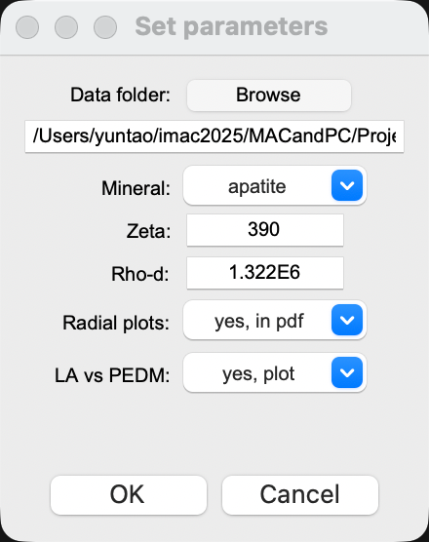
a. Select the Data Directory
- Browse to and select the folder containing your LA-ICP-MS fission track data files. These files must be formatted according to the provided template.
- Confirmation: Upon successful folder selection, a message will appear stating the number of valid CSV files found (e.g., "Selected folder with 8 CSV files"). This confirms the script has recognized the data to be processed.
- This selected directory will also serve as the output location. Outputs include radial plots, a excel file compiling the calculated ages, and associated statistics, and a comparison plot if choosing yes for “LA vs PDEM”.
b. Choose the Target Mineral
- From the dropdown menu, select the mineral you are analyzing (apatite or zircon). This selection influences default values and calculations.
c. Input Calibration Constants
- Enter appropriate values for the zeta (ζ) constant and the dosimeter track density (ρ_{d}) to calculate the number of pseudo-induced tracks (N_{ni}) via the pseudo-EDM approach.
- Recommended typical ranges:
  - For Apatite:
    - Zeta (ζ): 330 – 400
    - ρ_{d} (using CN2 glass): 0.8E6 – 1.8E6 cm⁻²
  - For Zircon:
    - Zeta (ζ): 100 – 130
    - ρ_{d} (using CN1 glass): 0.1E6 – 1.0E6 cm⁻²
d. Choose to generate radial plots or not
- The default for is “yes, in png”. In this case, two radial plots will be generated and saved in png format, one using traditional LA-ICPMS approache, and the other using pseudo-EDM. The plots can also be saved in pdf, if choosing “yes, in pdf”.
e. Choose to compare LA vs PDEM ages
- The default for “LA vs PDEM” is “yes, plot”. In this case, the code will generate a figure comparing the pooled and central ages, dispersion, and p-value calculated using LA (traditional LA-ICPMS) and PDEM (pseudo-EDM) equations. You may also ignore the comparison.
- The plot below is generated for the data files in the “data4demo_ZFT” folder. The figure compiles a comparison of pooled ages calculated using traditional LA-ICPMS and pseudo-EDM approaches (panel a), and the pooled-central age differnces against dispersion and pvalues (panels b and c).
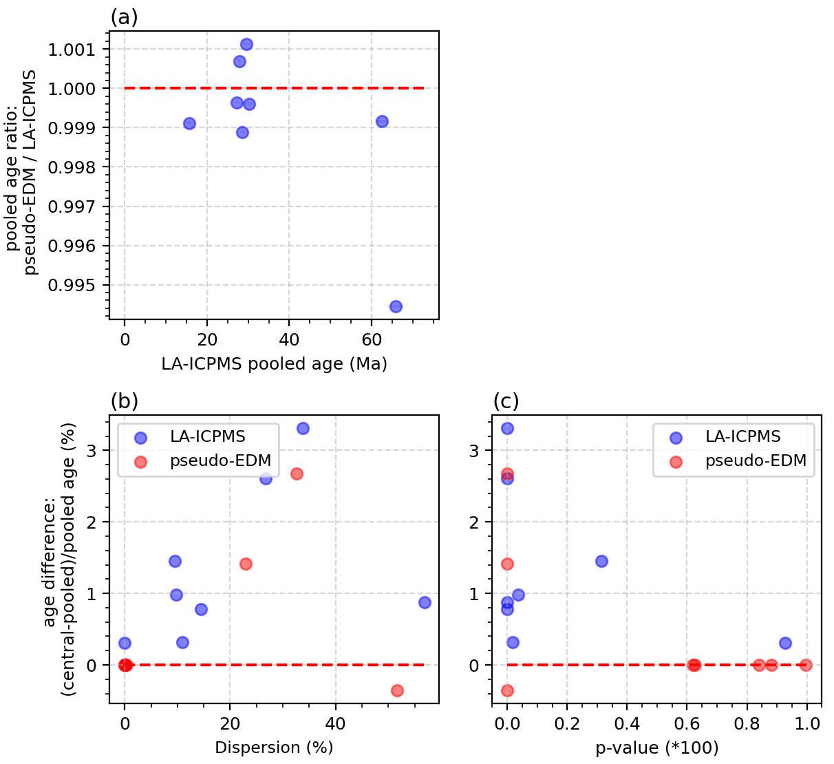
- If choose yes, the plot will be generated and a figure named 'LAICPMS_vs_pseudoEDM_comparison.png' will be saved in the Data Directory provided in the step a.
e. Execute the Processing
- Click OK to start the analysis, and Cancel to exit.
- The code will automatically process all qualifying sample files within the
- The script includes a validation check for the entered constants. If you input a ζ or ρd value that falls significantly outside the recommended typical ranges listed above, the code will halt execution. A warning message will appear in a dialog line above the OK and Cancel buttons. In this case, please review and correct the values before proceeding.
- Post-Execution State: After processing is complete, the parameter input fields in the UI will be disabled and turn gray. This visual cue indicates the run has finished, while allowing you to easily review the exact values used for the calculation without risk of accidental modification. The window will remain open for your reference.

5. Output Files and Plot Customization
After processing is complete, the script will generate the following outputs for each sample in your selected directory:
- Two Radial Plots for each sample: one is using the traditional LA-ICPMS equations and the other using the pseudo-EDM approach (with a postfix _pseudoEDM.png).
- A Single Excel File (ages_results.xlsx) that compiles the calculated ages and relevant statistics (e.g., pooled age, central age, dispersion, chi-square test results, p-values etc) for all processed samples.
- A PNG figure file comparing the pooled and central ages, dispersion, and p-values calculated using traditional LA-ICPMS and pseudo-EDM equations.

6. Customizing the Radial Plots
You can modify the appearance and quality of the generated radial plots by editing specific parameters in the plotting section of the script.
- Basic Plot Appearance:
Look for the line containing isoplotR.radialplot()—typically resembling isoplotR.radialplot(x=data, oerr=1). Adjust the arguments within this function call (e.g., oerr, show.numbers, pch) to change visual elements.
- Adjusting Plot Size and Resolution:
To decrease or increase the resolution and dimensions of the saved radial plots, locate and increase the values for these parameters before the plot generation:
radialplot_width = 500 # Default: 300 (width in pixels)
radialplot_height = 500 # Default: 300 (height in pixels)
radialplot_res = 150 # Default: 100 (resolution in DPI)
Higher values will produce larger, higher-resolution image files but may increase processing time and file size. Adjust these values to suit your publication or display requirements.

